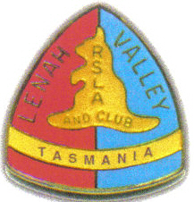

This is to certify that:

DOUGLAS WILSON

has been made a

Life Member

of the

Lenah Valley R.S.L. Community Club

on

Sunday 25th June, 2006

Signed:

________________
Don Grace, President

